Python Scripting – Automation

- Run the AFE44x0SPO2EVM GUI.exe
- Select ‘Scripts → Launch Macro Window’ from the run-time menu at the top.

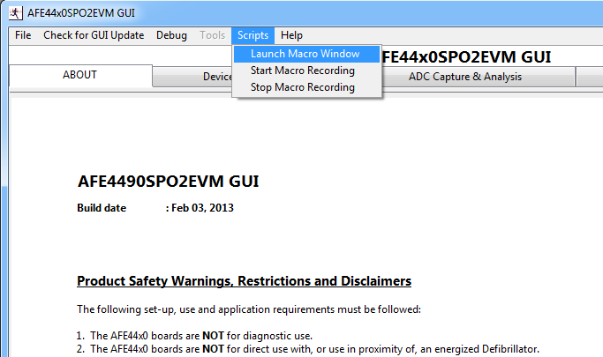

- If you want to record the operations done on the GUI, Please select ‘Scripts → Start Macro Recording’ and if you want to playback/execute already existing script, Please select ‘File → Open’ in the python window and select the file.

Start Macro Recording and Stop Macro Recording:

- You will a see a python window initialized and blinking after you select Start Macro Recording. (Blinking says it is recording the actions that are being done on the GUI).
- Carry on with the operations you want to perform on the GUI and Python window will automatically record them.

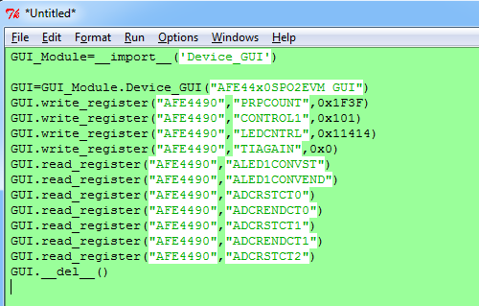

- Once recording is finished, Please select ‘Scripts → Stop Macro Recording’ and save the Python script file at desired location as ‘filename.py’

Sample Scripts are available in the folder called ‘Documentation’ parallel to AFE44x0SPO2EVM GUI.exe (C:\Program Files\Texas Instruments\AFE44x0SPO2EVM GUI\Documentation)

Functions Description:

- GUI.write_register(“Block Name”, “Register Name”, Data in hex)
- GUI.read_register(“Block Name”, “Register Name”)

- Block Name is “AFE4400” or “AFE4490”
- Register Name can be any one of the 48 registers in the device – Please refer low level page for these details.
- Data to be written has to be in hexadecimal. For Ex. : 0x5140

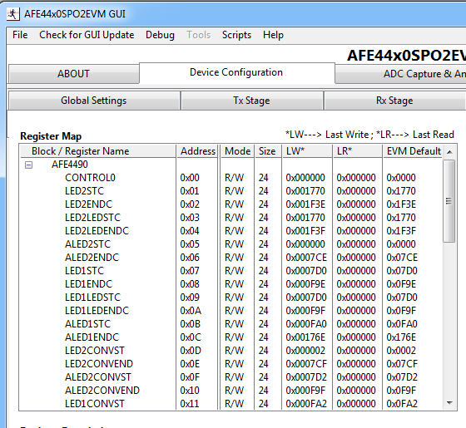

Troubleshooting:

- Python window not launching :
  - Make sure that python 2.7 is installed properly and the environment variables are set properly.
  - Run the C:\Program Files\Texas Instruments\AFE44x0SPO2 GUI\Scripts\Device_GUI.py and check if it has any errors. If errors are present try to get the latest EXE from website
  - Python will need the EXE running at the port mentioned in the key server.tcp.port = 6640 in the file C:\Program Files\Texas Instruments\AFE44x0SPO2EVM GUI\ AFE44x0SPO2EVM GUI.ini
  - If the EXE is running at different port, please update this key in the configuration file

